Developing Contact in the Young Gaited Horse

When we think of contact with the gaited horse, we have to explore much further into the gaited horse’s mouth and look at different concepts and terms that shape our trail horse’s needs. One area of confusion is having so many different ways to describe “contact with the bit.” Make no mistake about it, this is the most difficult task of communication you will obtain with your horse. Just for fun, ask five good riders what the term, “contact with the bit” means to them and I’ll bet you get five different answers. Now let’s take this a step further. We live in what is known as the “Information Age.” To help us communicate we use telephones, radios, televisions, cell phone, pagers, e-mails and satellite communications systems. Even with all this technology, we still can’t talk to each other without dropped calls and other human confusions. Add all the difficulty with communication to so many different bitting methods, and the pressure of trying to communicate with your horse can become overwhelming and frustrating.

The good news is that bitting the young horse does not have be a mountain to climb without ropes. To develop contact, we must define it as a total package of seat-leg-hands, which is taken one step at a time, and slowly. You must have a stable seat, meaning a seat that allows you independent balance from your hands. For this reason its best we start with a snaffle bit that offers tongue relief and then progress to the shank bit. A snaffle bit that offers relief and is more forgiving with the young horse; he will tolerate this training process more easily. 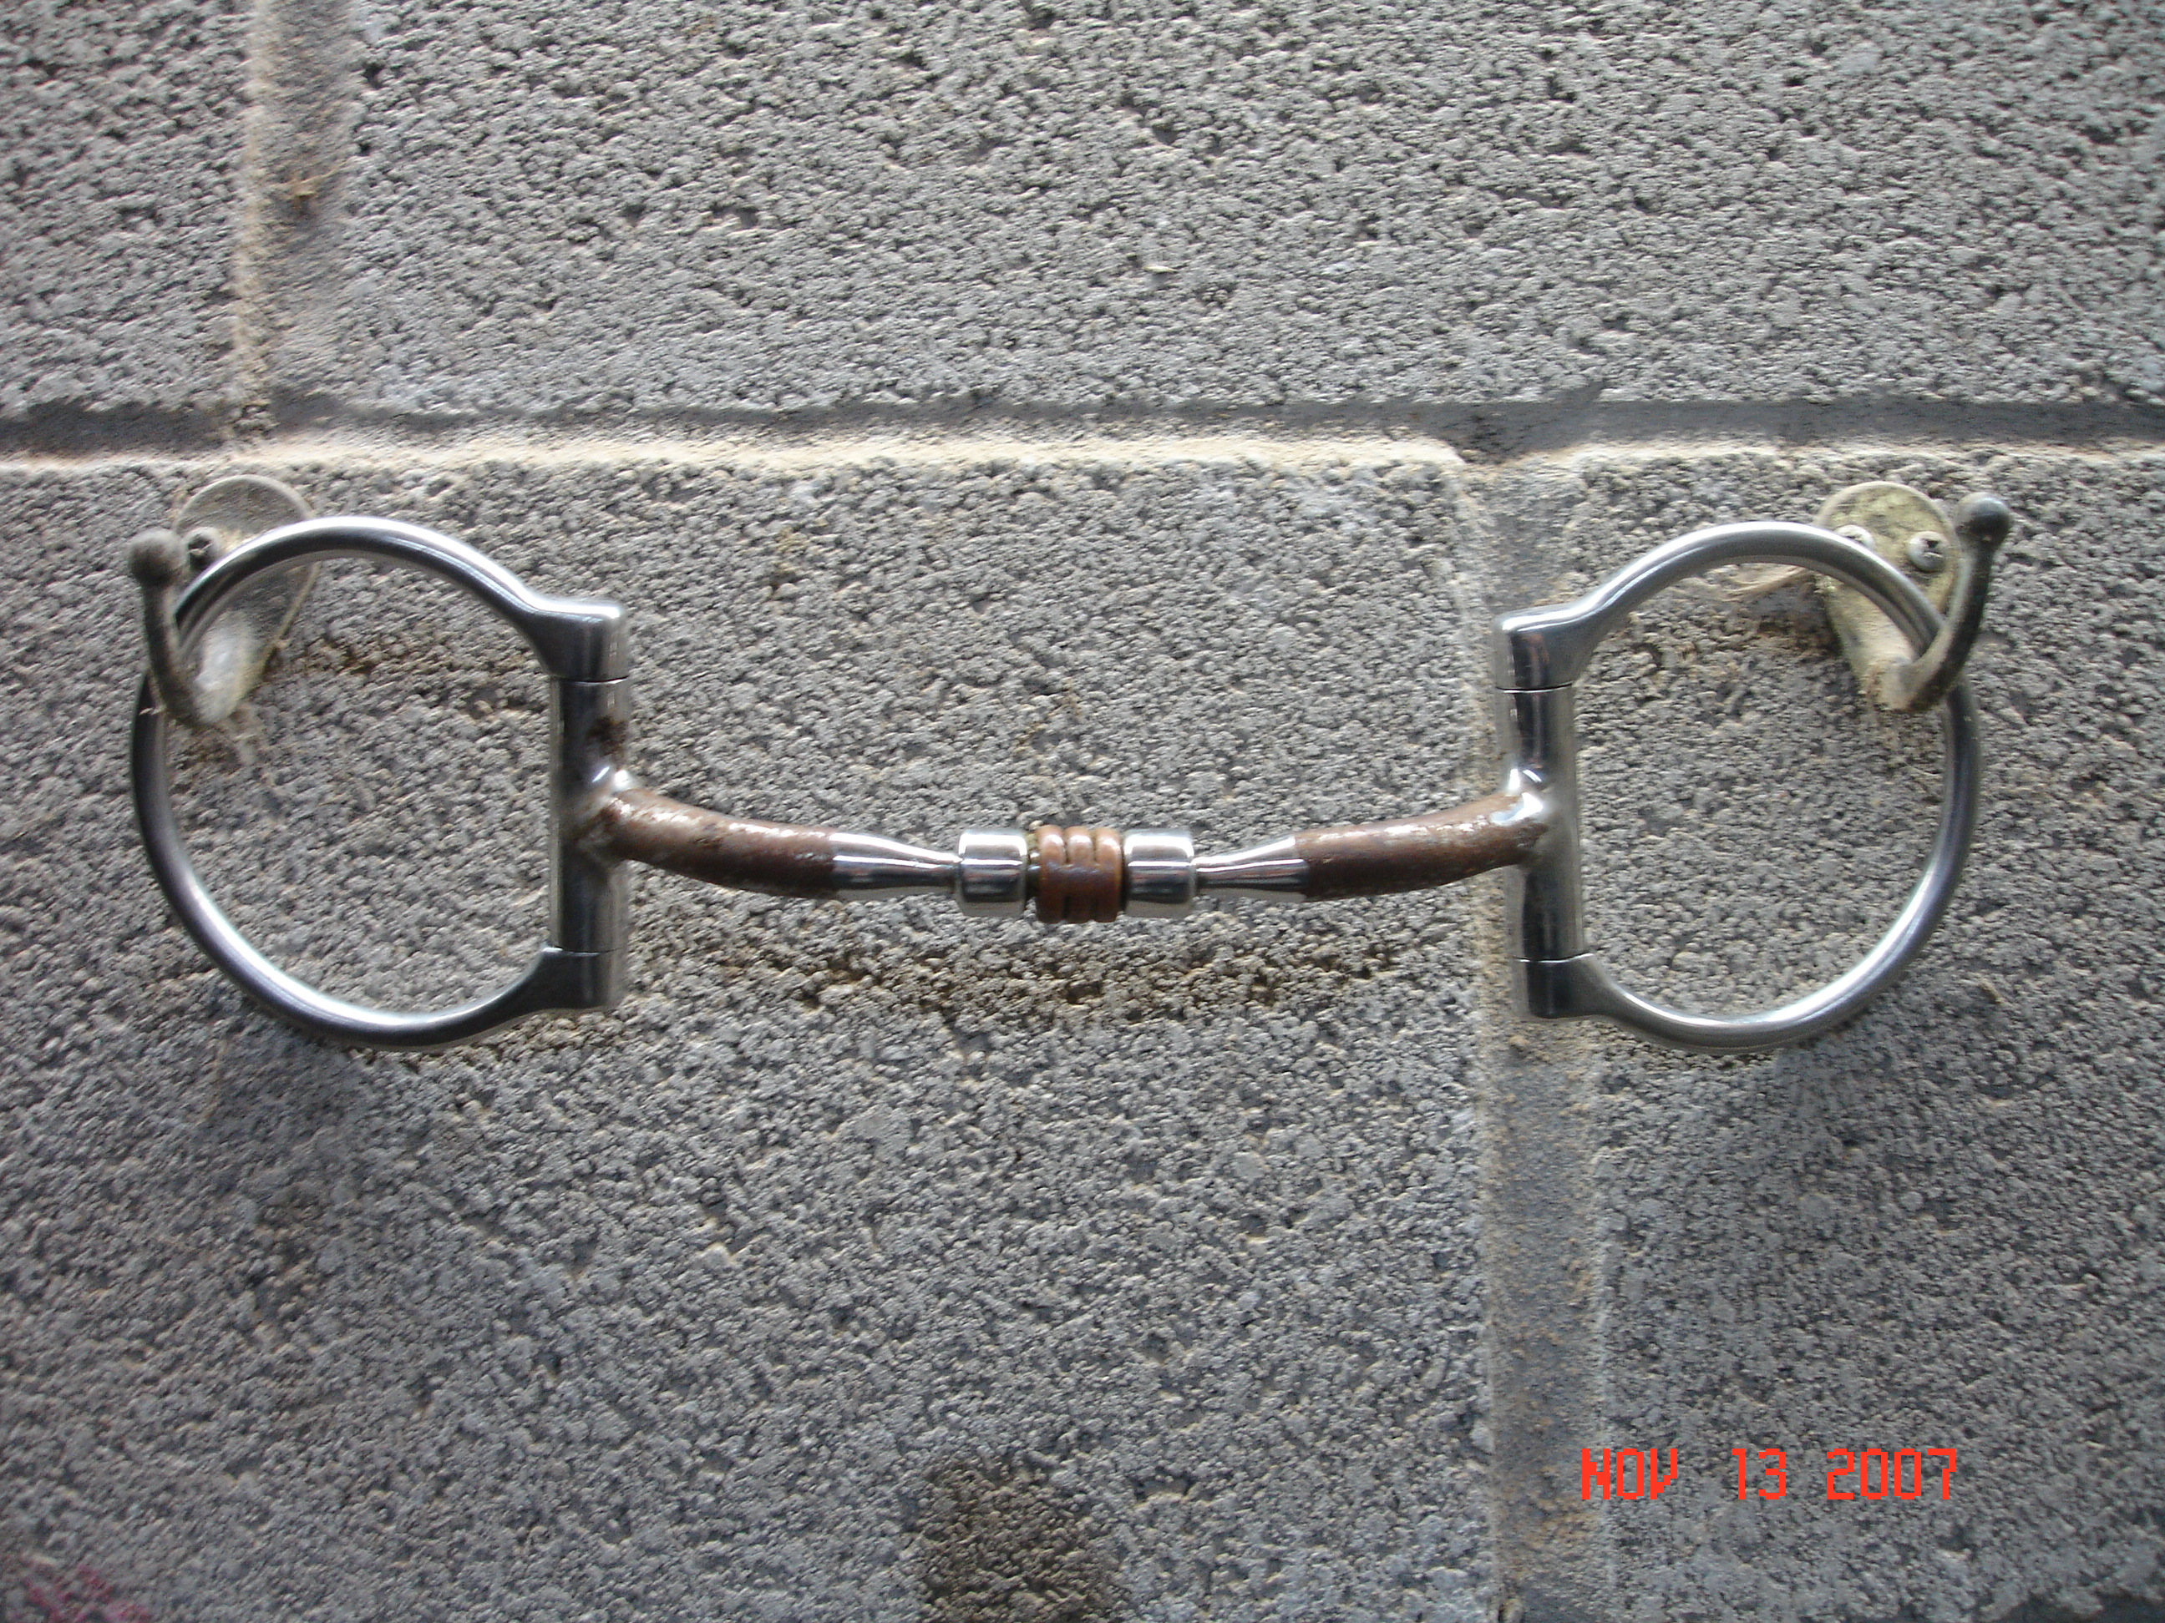 If you don’t have an independent seat, please seek professional help before you start developing contact under saddle. Having a good equine dentist evaluate your horse’s mouth is also a wise move.

Looking inside of your horse’s mouth you will see potential pressure points: the tongue, lower jaw bars, and the roof of his mouth. Now the real point I’m trying to make is that if you look closely, you will find his heart and soul located where you are going to hang a piece of metal. Always keep this in mind, you can have the best equipment (bits, saddles, bridles, books) and training theories known to mankind but without understanding correct contact, you don’t have much. Many people buy a horse that is gaiting great when purchased, and then wonder what happens a few weeks later to their horse’s gait. More than likely it’s a contact problem. Too much contact with a shank bit usually leads to rearing, head tossing, refusing to turn (most of the time to the right), high head, hollow back, rushing, and the list goes on and on. With too little bit contact, the horse flops around on the forehand like a fish out of water and does not developing his engine, the hindquarters. The old saying, “the only bit that works on a horse is a bit of knowledge,” is as true today as it was 100 years ago. Remember we could spend days or weeks on this subject. For an entry level starting point let’s look at just three basic concepts of developing contact: Hold, Release, and Reward.

Rocky Mountain horses, Kentucky Mountain horses, Tennessee Walking horses and Missouri. Fox Trotters are different breeds, but they all have one thing in common. Each individual horse must be taught a complete understanding of the release of pressure as a reward. When you take a young child for a walk with no traffic around, as long as he is safe you don’t hold his hand. You release his hand and let him play. If he starts doing something you don’t like, or you come to a busy street, you again will take hold of the child’s hand. This is the same concept with your young horse. When the horse is doing well, or doing what you want, release the hold for a reward. I use the term “hold” because that’s what bitting (using a bit) is all about--“holding” (not “pulling”). When you put the bit in the horse’s mouth, the desired effect is for the horse to act upon the bit, not the bit upon the horse. Just look around on the trails or horse shows you will see rider after rider forcing the bit to act upon the horse.

I firmly believe the gaited horse needs tongue relief to gait properly. A snaffle bit is a non-leverage bit that has no curb/leverage action. A snaffle is jointed in the middle and has many variations of rings: D-ring, egg butt, and other combinations. When used correctly this bit sends one signal at a time, exerting less pressure on the tongue, bars, lips and corners of the mouth A mild snaffle bit signal gives us an opportunity to put pressure in the horse’s mouth without causing an overreaction, especially in the young horse. Why? Because you don’t restrict the horse’s tongue. The key is to keep the horse calm and not give him a reason to react. As a general rule: the thicker the mouthpiece the milder the bit, and the thinner the mouthpiece the more severe the bit.

To begin, place your snaffle bit and bridle on the horse without reins. Now for the first few bittings, don’t have the bit pulled up into the corners of the horse’s mouth, creating wrinkles. Just apply a nice fit almost to the corners of the mouth. We want the horse to lift and hold the bit himself. If you start out with the bit creating wrinkles in the horse’s mouth you have already established no-release contact. Let the horse wear this around in the corral for few days, getting used to lifting and mouthing the bit. Ten to twenty minute sessions are fine. Just stick around so if he gets into trouble you’re there to help. After three or four sessions the horse will stop mouthing and will accept the bit. Now add your reins to the snaffle bit and stand beside him. Pick up the left rein in your left hand, hold it still and then squeeze your hand (fist). You are now putting pressure on the horse’s tongue, lips, and left corner of his mouth. Hold this pressure until the horse gives by moving his nose and eye to the left, and immediately Release the pressure for the Reward.

Step to the right side of the horse, pick up the right rein in your right hand, hold and squeeze. You are now putting pressure on the horse’s tongue, lips, and right corner of his mouth. Hold this pressure until the horse gives by moving his nose and eye to the right, then instantly Release this pressure for the Reward. The amount of weight or pressure you put on the reins is like holding two baby birds. Add only a small amount more pressure if needed. It’s important that you maintain the hold and give only when the horse gives first.

How long should you practice this concept? This training is progressive in nature and will need to be presented to the horse with the same applications at different stages of development, later using the shank bit, which works off the bars of the mouth. I’ll have more on that in another lesson. The key for now is to take your time and train slowly to build a good foundation in the horse’s mouth. You want him or her to understand that the bit is associated with a reward for giving the right response. Keep working towards lightness, and never dull the mouth. You probably already guessed you are teaching what is called “Classical Conditioning”. When you get this right, the sky is the limit. If you need help with this concept you can contact me at Windsweptstables.net or
windsweptstables@hotmail.com 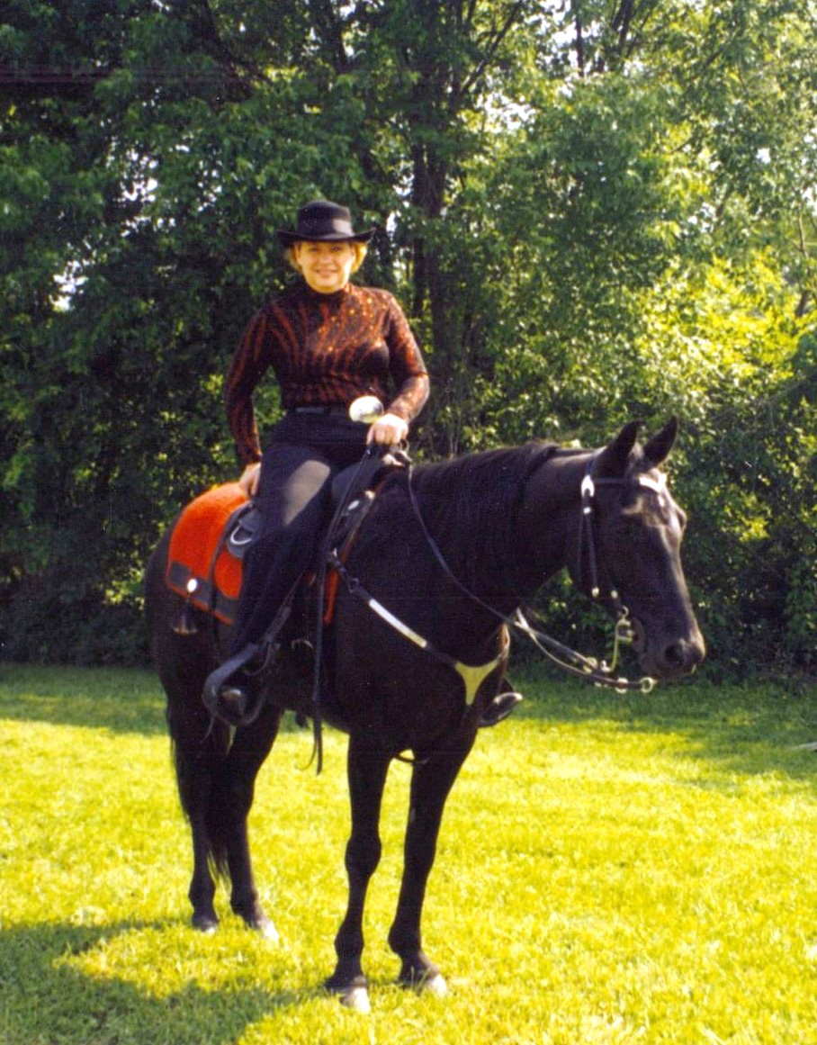

Happy Trails.

Gary Lane

