All good horsemen and horsewomen will agree with this saying SEAT-LEGS - HANDS coordinated together in a smooth action to assist the horse to achieve his foundation gait. Have you ever wonder why this saying starts with the seat first. The seat is the control center that starts all requests and fine-tunes the balance of the horse to the hindquarters. As riders it is our responsibility to ride the horse from the hindquarters forward. The seat when used properly will hold the horse together and assist the horse in developing a consistent gait for a smooth and gliding ride. When I think of the gaited seat I think of a total seat that involves your two seat bones, pubic bone, and the thighs that supports a soft feel. In the old days growing up on a farm I always seen people using three point stools/legs to milk cows as opposed to four points stools/ legs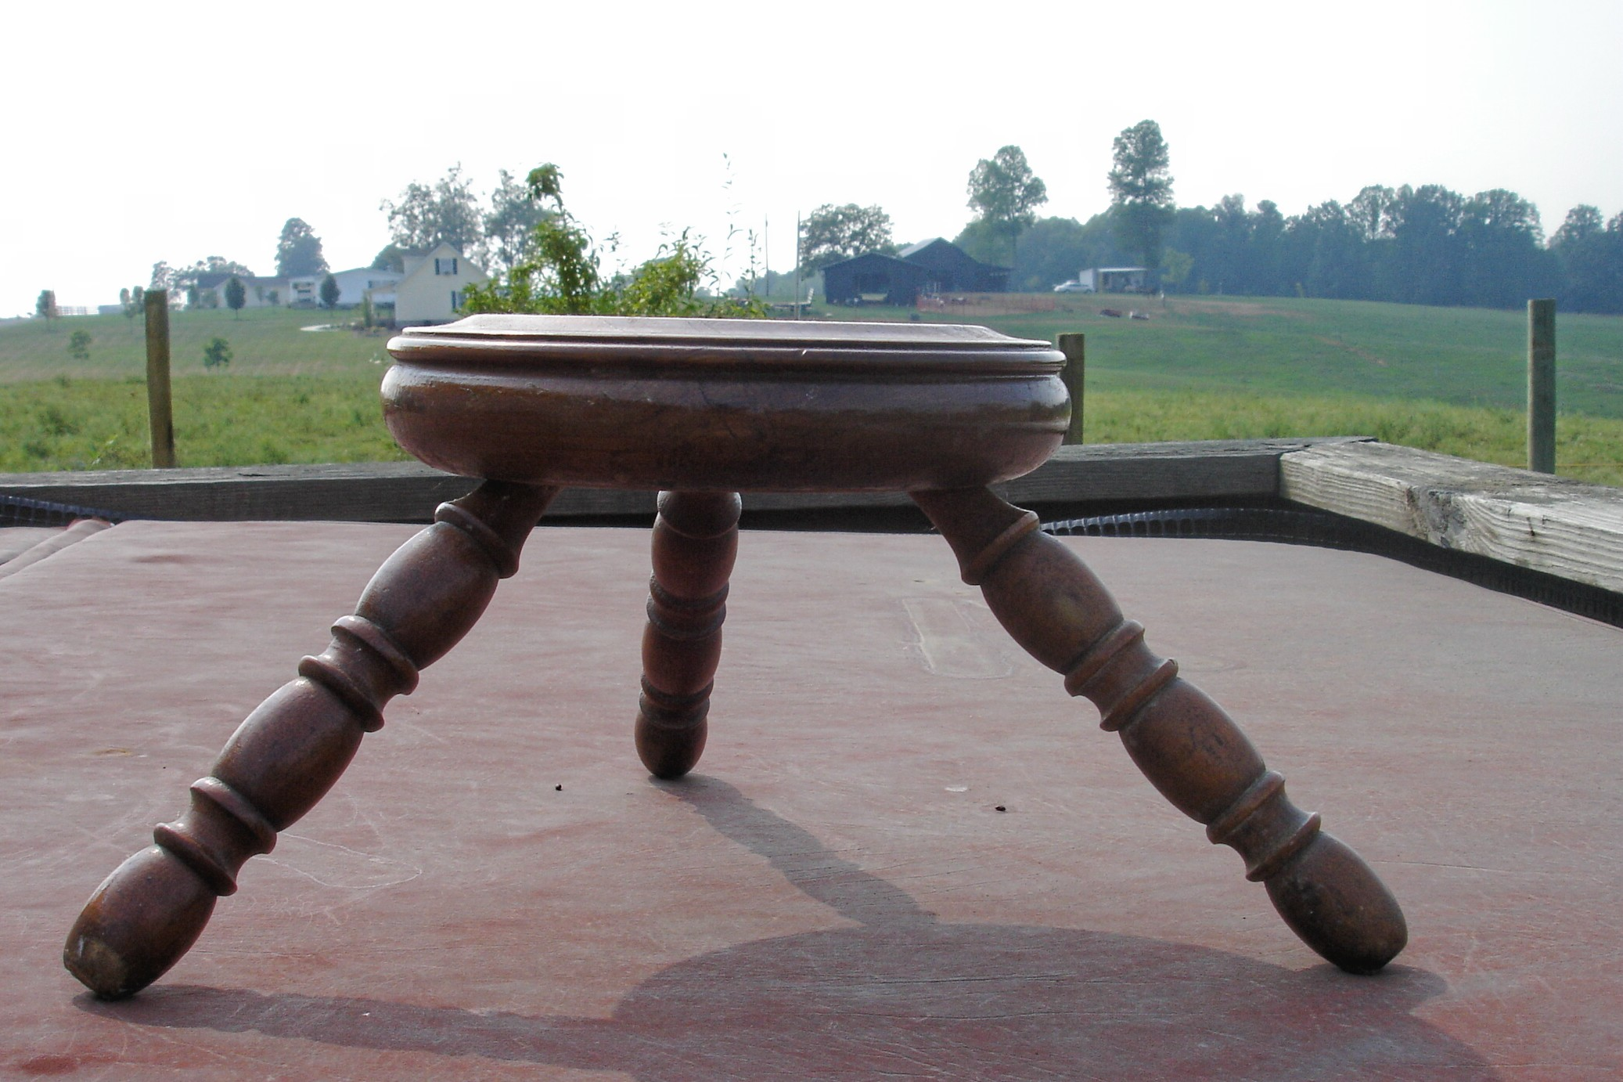. Why because the three point stools were stronger and supports weight better. Keeping your two seat bones and pubic bones deep on the saddle also forms a three point base triangle offering the same stable support Taken a step further it can make all the difference in the world with safety when you ride your trail horse. You do not have to be an Olympic rider competing for a gold medal to get the benefits of a stable seat. Remember a good seat is a lasting impression on your horse’s back. Your horse knows if you care about his back and by the way that’s where his gait is located more on that later. Lets take a closer look at the SEAT and how it affects you and your horse.

Lets start by looking at a rider’s profile. Seeing a plum in your minds eye. You want to see the ear, shoulder, hip, elbows, and ankles in a near vertical line. 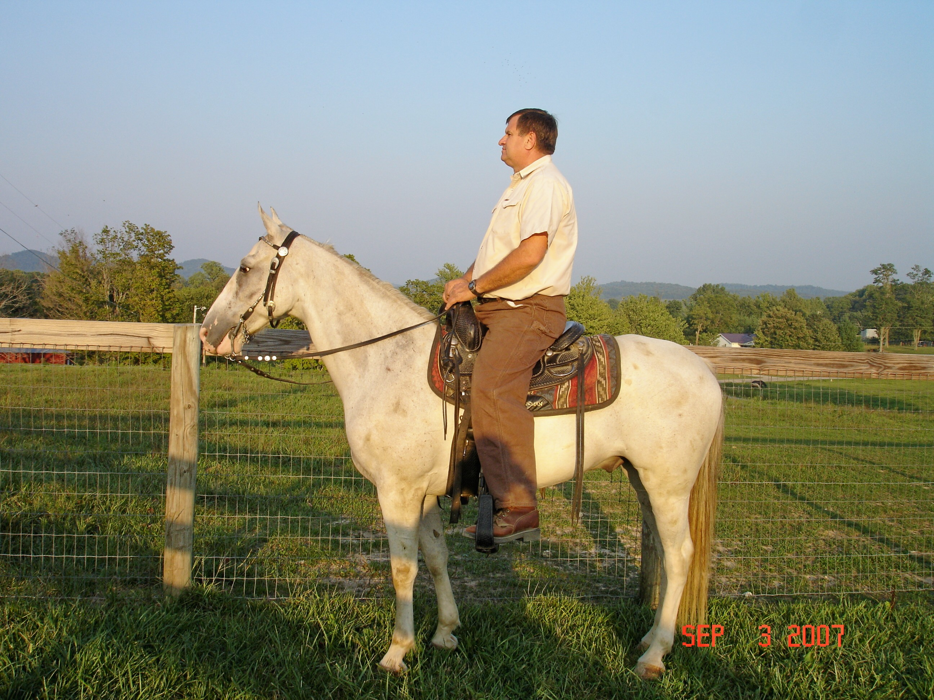 How do we achieve this? Start by getting your two seat bones deep into the saddle. Sit in the saddle like you see a jockey sitting on his horse. This position puts your two seat bones deep in the saddle. When taking a break on your horse’s back, this is a great position to rest your horse’s back. Now you want to drop your legs onto the horses side and let them fall around the horse’s sides like you would lay a lead rope across his back. Now here is the key, Line up your pubic bone, belly button, and sternum, in a straight line to your shoulder or collarbone. You actually rotate your pubic bone up and forward to come in line with your stomach and chest. When this alignment, lines up it will form a tee when intersecting with your shoulders. You now should be sitting on you seat bones not your pant pockets. You will also feel your pubic bone touching the saddle. Fill in the rest of the seat with your thighs letting your heels go slightly downward. In this new seat just take a deep breaths into your stomach or belly breath. This will release your back for great trail rides. This position may feel awkward but give your self-time to develop this concept.

Remember when you ride with your legs stuck out in front of you like your setting in a recliner chair or when you are a passenger in a pickup truck Putting your feet on the dash board of the truck. You are behind the motion of the horse. When in this position the seat bones are driving into the horse’s back more than likely this will result in a high headed horse with a hollow back doing a tail bobbing lick meaning, the hindquarters are disconnected, and the horse is cut into. In this mutated seat position the rider is usually leaning backwards and the pubic bone is off the saddle. This seat position can also produce a stepping pace or hard pacing action.

When you sit on your pubic bone and lean forward and off your seat bones this is a perched position. You are now putting your horse on the forehand. What happens is the horse never truly comes through from the rear hindquarters. He becomes very heavy in hand. This heaviness requires for you to support your horse constantly. This mutated seat will develop a fifth leg to support your horse movement. Meaning your hands to hold up horse’s head. Your hands become very busy. The over active hands ads even more problems for the trail horse.

All of this talk about seat, legs and hands seems to be overkill for the weekend trail riders. You may ask your self is it worth learning to ride from the rear forward. The answer is absolutely yes. When you line up your pubic bone, belly button, sternum, and collarbone to form a tee with your shoulders. You are freeing up the top line. You are now letting the power come across the back from the hindquarters to the horse’s mouth into your hands. Your legs are underneath you with a soft feel on the horse’s sides. All of this action serves to recycles forward energy and balance to the horse’s motion no matter how tough or extreme the trail footing. Using a good lined up balance seat and riding slowly you can develop a great gearbox into the flat walk no matter what breed of gaited horse your ride. 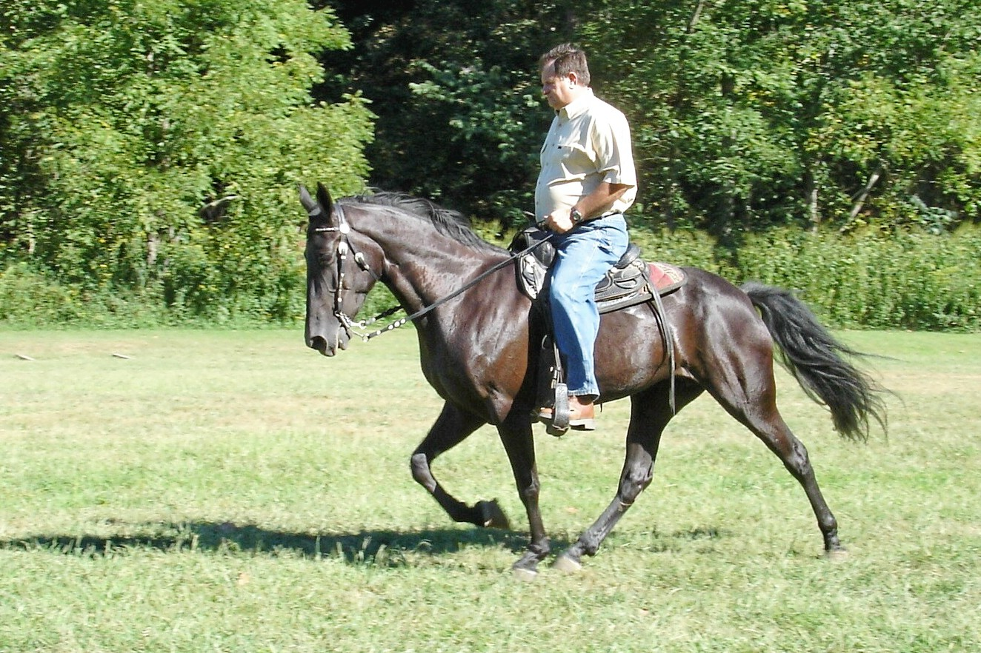 If you need help with this concepts feel free to contact me at windsweptstables.net or windsweptstables@hotmail.com

